

International School

**Capstone Project 1**

*CMU-SE 450*

**Architecture Design**

*Version: 1.0*

*Date: 08/09/2021*

**School Connect Application**

**Submitted by:**

Nguyen Thanh Phu

Nguyen Trung Hieu

Dang Nguyen Bao Hoai

Nguyen Van Thang

**Approved by**

Nguyen Minh Nhat

**Architecture Design Review Panel Representative:**

Name Signature Date

**Capstone Project 1- Mentor:**

Name Signature Date

# Project Information

|  |  |  |  |  |
| --- | --- | --- | --- | --- |
| **Project acronym** | SConA | | | |
| **Project Title** | School Connect Application | | | |
| **Start Date** | 22-Aug-2021 | **End Date** | | 18-Dec-2021 |
| **Lead Institution** | International School, Duy Tan University | | | |
| **Project Mentor & contact details** | Name: Nguyen Minh Nhat  Email: nhatnm2010@gmail.com  Tel: +84 905 125 143 | | | |
| **Scrum Master & contact details** | Name: Nguyen Thanh Phu  Email: [thangphu104@gmai.com](mailto:thangphu104@gmai.com)  Tel: +84 772 492 301 | | | |
| **Team members** | **Name** | **Email** | **Tel** | |
| Nguyen Trung Hieu | hnguyentrung20@gmail.com | +84 975 299 149 | |
| Dang Nguyen Bao Hoai | dangbhoai@gmail.com | +84 773 305 395 | |

|  |  |  |  |
| --- | --- | --- | --- |
| **DOCUMENT INFORMATION** | | | |
| **Document Title** | Project plan | | |
| **Author(s)** | Team C1SE.44 | | |
| **Role** | C1SE.44- Architecture Design -SConAdocx-v1.0 | | |
| **Date** | 08-Sep-2021 | **Filename** | C1SE.44- Architecture Design -SConA.docx-v1.0 |
| **URL** | **https://github.com/PhuNguyenThang/Capstone1** | | |
| **Access** | Project and CMU Program | | |

**DOCUMENT APPROVALS**

The following signatures are required for approval of this document.

|  |  |  |
| --- | --- | --- |
| Nguyen Minh Nhat  *Mentor* | Signature | Date |
| Nguyen Thanh Phu  *Scrum Master* | Signature | Date |
| Nguyen Trung Hieu  *Product owner* | Signature | Date |
| Dang Nguyen Bao Hoai  *Product owner* | Signature | Date |

REVISION HISTORY

|  |  |  |  |  |
| --- | --- | --- | --- | --- |
| **Version** | **Date** | **Comments** | **Author** | **Approval** |
| 1.0 | 08-Sep-2021 | Create Architecture Design Document | Nguyen Thanh Phu |  |

TABLE OF CONTENTS

Project Information 2

1. Introduction 5

1.1 Project overview 5

1.2 Purpose 5

2. Architecture driver 6

2.1 Business constraints 6

2.2 Technical constraints 6

2.3 Functional requirement 6

2.4 Quality attributes 6

3. Architecture overview 9

3.1 System context 9

3.2 Component and connector 11

3.3 Sequence diagram 13

3.4 Module view 18

3.5 Allocation view 19

4. ATAM 20

4.1 Present the ATAM 20

4.2 Present the business Drivers 20

4.3 Present the Architecture 20

4.4 Identify the Architecture approaches 20

4.5 Create a Quality Attribute Tree 21

4.6 Analyze the Architectural approaches 21

4.7 Brainstorm and prioritize scenarios 22

4.8 Re-analyze the architectural approaches 22

4.9 Present the results 22

5. References: 22

# Introduction

## Project overview

The School Connect Application is a miniature social network for school, this application help connect between student and school in epidemic context. Students do not need come to school to hear announcements about upcoming events or new policies, school can use this application for notify to students about policies of school. Teacher can keep contract with student without using another app and don’t worry about personal information network social network exposed, student can create post in the forum their join and see calendar of event will take

With intuitive visual interface will help the teacher and student easy to using system

This only for student and teacher in that school, so school can manage all account using in the system and censor is teacher can manage all post and member in the forum them manage

## Purpose

This specification covers following:

* Brief specification of the project, high level requirement.
* Detail quality attribution.
* System context, sequence diagrams.
* Architecture presented by various view types: Component and Connect, Module view and Allocation view.
  1. Business driver

Business Problems:

* Annoying when having to receive emails or messages in social networks to solve petty problems.
* Professors and students may not use the same communication tools so they must use many app to can chat together.
* [During pandemic] students may not know each other, and it is difficult to work as a team.
* Messages and notifications from professors and school clubs always miss because they do not have a separate communication channel.
* Censorship of bad conversations and comments is very difficult.
* Security: using third party apps made information of students or teachers can be exposed.
* There are too many to post and the comment bad to be checking.

Business Need:

* Private and security from the outside.
* Notification about events or policies for students and teachers.
* Easy students and teachers can contact together.
* No effect on personal social media accounts.
* Manager in information student and teacher
* Manager all forums in system
* Control posting, commenting and chat.
* Students and teachers can report comment or message toxic.

# Architecture driver

## 2.1 Business constraints

* Sources: 3 people.
* Project was started on: 22-Aug-2021
* Project will be ended on: 18-Dec-2021
* Project will be finished in 119 days (893 hours).
* Cost: $2266.

## 2.2 Technical constraints

Technical to develop:

* Programming Language: Java, JavaScript.
* Frameworks / Libraries: Vue, Spring Boot, Bootstrap 4, Axios.
* Database Management System: MySql, FireBase.

Environment:

* Web browsers: Google Chrome, Opera.
* Operation systems: Microsoft Windows 10.

## 2.3 Functional requirement

References to Product Backlog specification of ProductBacklogV1.0.docx

## 2.4 Quality attributes

2.4.1Utility table

There are following quality attributes that drive the design of architecture. Each quality attribute scenario is ranked with importance (I) defined by the Product Owner, and the estimated level difficulty (D). Both values are based on a scale of High (H) - Medium (M) - Low (L).

**2.4.2 Quality attributes**

#### 2.4.2.1 Security

|  |  |
| --- | --- |
| Scenario: when admin, student, teacher want to using website they need login to the system | |
| Quality Attributes | Security |
| Stimulus | Using website application |
| Source(s) of stimulus | Student or teacher, censor, admin |
| Artifacts | Information in system |
| Environment | Normal operating system |
| System response | Require user to login |
| Response measure(s) | Prevent access to the website without login |

|  |  |
| --- | --- |
| Scenario: When a account user registers by admin, their password will be encrypted security before being saved to database | |
| Quality Attributes | Security |
| Stimulus | Create new account |
| Source(s) of stimulus | Admin |
| Artifacts | System |
| Environment | In runtime |
| System response | Encrypt password |
| Response measure(s) | Encrypted security before being saved to database |

#### 

|  |  |
| --- | --- |
| Scenario: Only user have role “CENSOR” can to censorship member, post or delete post of another user in the forum | |
| Quality Attributes | Security |
| Stimulus | Censorship member, post or delete post of another user |
| Source(s) of stimulus | Student or teacher |
| Artifacts | System |
| Environment | Normal operating system |
| System response | Do not expose those functions to the user |
| Response measure(s) | Requires users have role “CENSOR” to be able to use that function |

#### 2.4.2.2 Performance

|  |  |
| --- | --- |
| Scenario: student and teacher send message, this message will be send to recipient in 10 seconds | |
| Quality Attributes | Performance |
| Stimulus | Sent message in the system |
| Source(s) of stimulus | Student or teacher, censor |
| Artifacts | System |
| Environment | Normal operating system |
| System response | The person receiving the message will receive the message |
| Response measure(s) | In 10 seconds |

|  |  |
| --- | --- |
| Scenario: student, teacher, admin create the post, user has join the forum have new post will be receives the message in less 15 second | |
| Quality Attributes | Performance |
| Stimulus | Create post in the forum they join or manage |
| Source(s) of stimulus | Student or teacher, censor, admin |
| Artifacts | System |
| Environment | Normal operating system |
| System response | Another user receives notify from new post |
| Response measure(s) | In less 15 second |

#### 2.4.2.3 Correctness

|  |  |
| --- | --- |
| Scenario: When the student, teacher, admin operations with a tour including adding, modifying, and deleting the post, the corresponding post information will be updated correctly on the application. | |
| Quality Attributes | Correctness |
| Stimulus | Performs operations with a post |
| Source(s) of stimulus | Student, teacher, admin |
| Artifacts | Runtime |
| Environment | The System |
| System response | Change the information post |
| Response measure(s) | The corresponding tour information will be updated correctly on the application. |

#### 2.4.2.4 Modifiability

|  |  |
| --- | --- |
| Scenario: A product manager wants to develop additional features for a small social network in the next release. The system allows for expansion within 4 months of effort without affecting existing functions. | |
| Quality Attributes | Modifiability |
| Stimulus | Develop additional features for a small social network |
| Source(s) of stimulus | A product manager |
| Artifacts | The next version |
| Environment | The system |
| System response | Allows for an expansion |
| Response measure(s) | 4-person months of effort without affecting existing functions |

# Architecture overview

This section shows the diagrams which bounds our target system and describes the architecture and interaction between components

## 3.1 System context

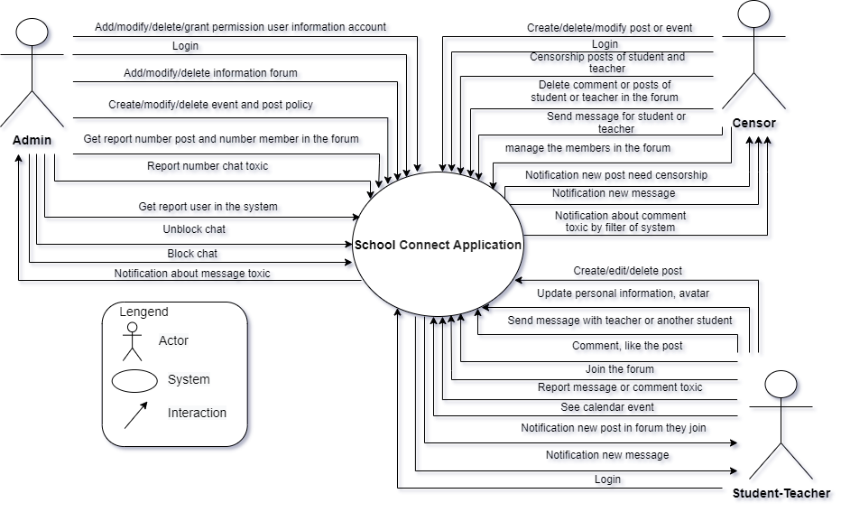

**Figure 1: System Context Overview**

* **Student - Teacher (user):**

Notification new post forum they join.

Create/edit/delete the post in the forum they join.

Login into a website.

Comment and like the post of they or another people.

Send a message to the teacher or another student in the system.

Update personal information, avatar.

See calendar event.

Join the forum.

Report message or comment toxic.

Notification new post forum they join.

Notification of new message

* **Censor:**
* Create/delete/modify the post or event
* Login into a website
* Censorship the new posts of student or teacher
* Sent message to student or teacher in the system.
* Delete comments, posts in the forum.
* Notification about comment toxic by the filter of system or teacher and student report
* Notification of the new post in the forum
* Notification of new message
* Censorship the request joins forum of the student or teacher
* Remove members from forum
* **Admin:**
* Add/modify/delete/grant permission student information account.
* Add/ modify/delete/grant permission teacher information account.
* Add/ modify/delete/grant permission censor information account.
* Add/modify/delete the forum.
* Add/modify/delete event or post policy.
* Report number chat toxic filter by system or student and teacher report.
* Report number posts and number members in the forum.
* Login into a website.
* Block chat toxic.
* Notification about message toxic filter by system or student and teacher report.

## 3.2 Component and connector

We mainly used a C&C view to argue and reason about architectural properties, quality attribute requirements, and functional requirements that the system must add here.

This view type partitions the system into components that have some runtime presence such as processes, objects, data stores, and connectors or that represent pathways of communication such as data flows and access to shared storage.

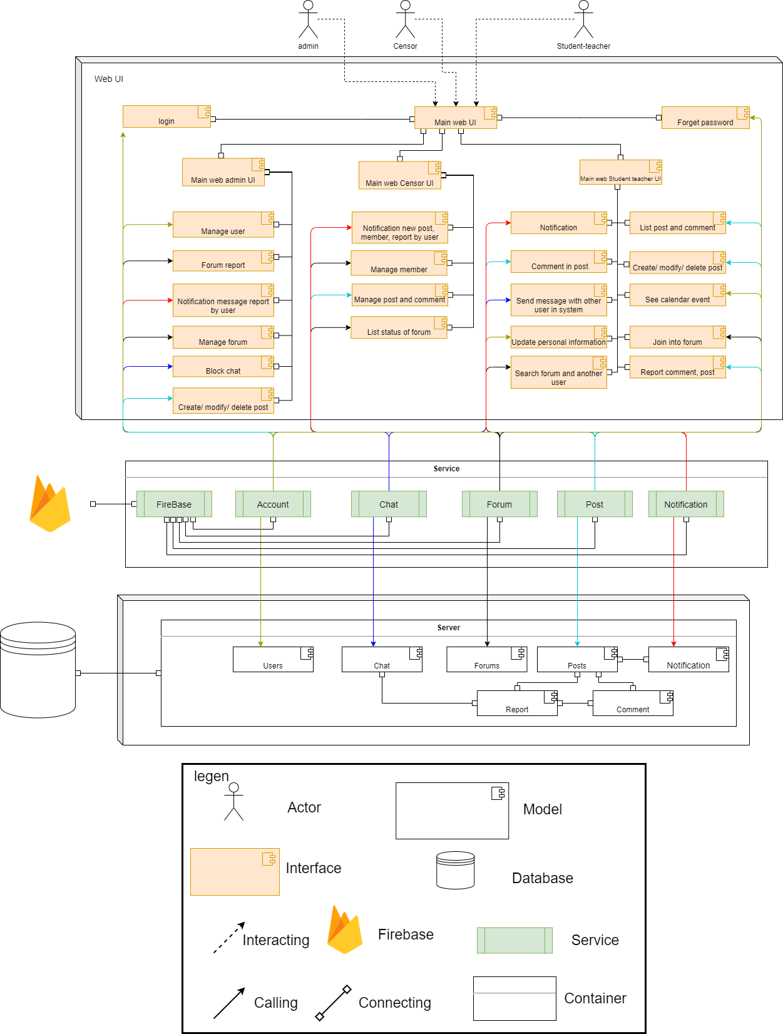

**Figure 2: C& C for SConA Website**

**Prose**

The webUI sends and receives data from the server through the web service API. User operations will send requests to the server through the API, the server will process the data with the corresponding models and access the database to retrieve data, then respond to the information to the web client through the API to display it to the user

|  |  |
| --- | --- |
| **Element** | **Responsibilities** |
| WebUI | WebUI is a component that manages and implements interactive functions for users that are handled on the UI. WebUI interact directly with users, receive requests and call APIs from Service to handle and return results. |
| Service | Service is a component that manages and performs activities related to retrieval and storage of data such as get the information list, user authorization. |
| Server | Server connect to tables in the database for transmission to the system interface |
| Account service | Service API in the backend to create, modify, delete user and login to the system. |
| Chat service | Service API in the backend create room chat for user and send chat both two users |
| Forum service | Service API in the backend create, modify, delete, forum and manage information have in forum like member, post, comment in forum |
| Post service | Service API in the backend create, modify, delete, post and user can comment in that post |
| Notification service | Service API in the backend create notify for user can know about new activity. |
| Firebase service | The service provides image storage solutions |
| Database | Database is a component which contains information of users, forum, post, chat.... All data the system needs |

## 3.3 Sequence diagram

Sequence diagram is used to display the sequence of activities. Sequence diagrams show the workflow from a start point to the finish point detailing the many decision paths that exist in the progression of events contained in the activity

**3.3.1 Login**

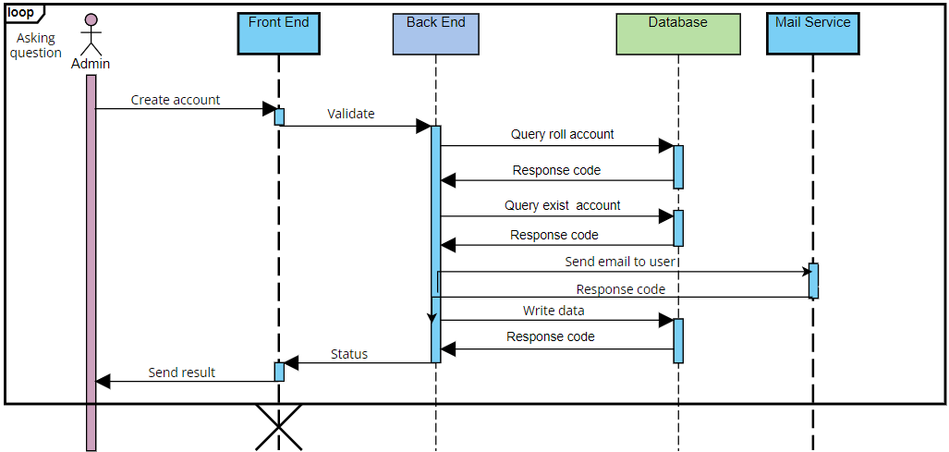

**Description:**

In order to use the SConA system, users have to login at first by using username and password. Our system receives requests, authenticates and returns login status.

If login successfully, one token will be create and save in the cookie users can use all functions of the system in their permission. Otherwise, their access will be denied.

**3.3.2 Create Account**

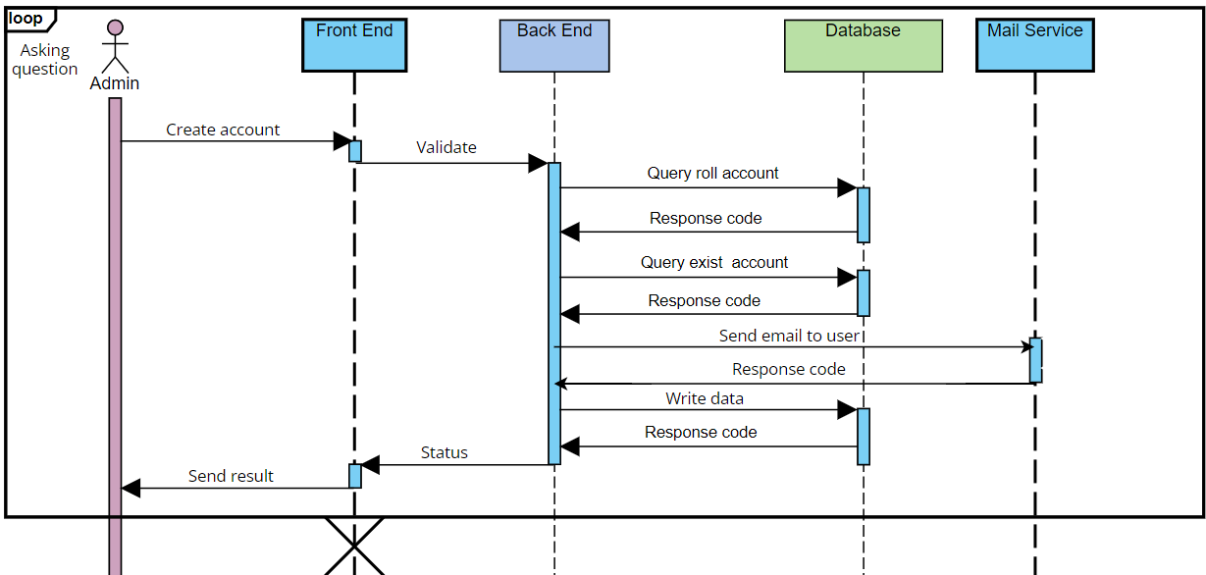

**Description:**

To login to the system, user have to account created by admin first.

Admin are allowed to create a new account, to do that admin create a new account with code, username, email, password, full name, position, role, address, number phone, gender, date of birth. The system will check if the information is valid will save in the database and send email for user

**3.3.3 Create forum**

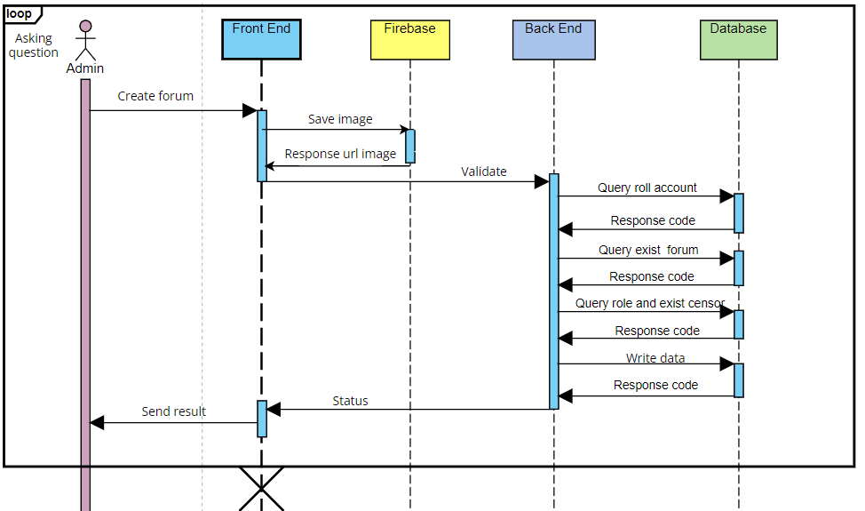

**Description:**

To join to the forum, admin need create forum first.

Admin are allowed to create a new forum, to do that admin create a new forum with name forum, select manager forum, description and choose cover image. Cover image will be save in the firebase store and save URL image and information of forum was check valid in the database

**3.3.4 Create post**

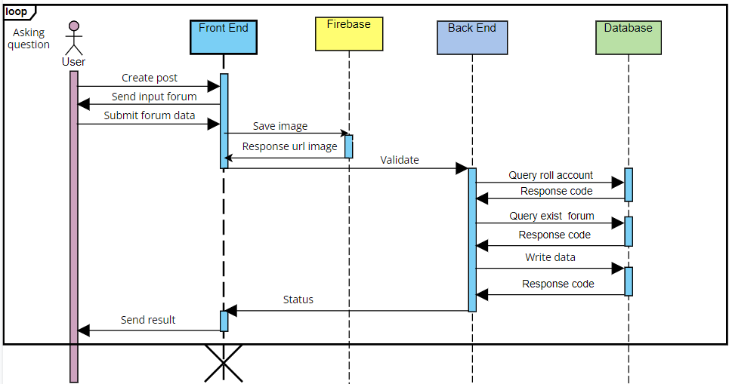

**Description:**

User are allowed to create post in the system, to do that they have to choose that thing they will post is normal post or event. If is normal post user will fill content of post and choose image if have. If that is the event user need fill name of event, content of event, address of event, date and time of the event. If have image so that will be save in firebase and URL and information of post will save in the database

**3.3.5 Censorship member**

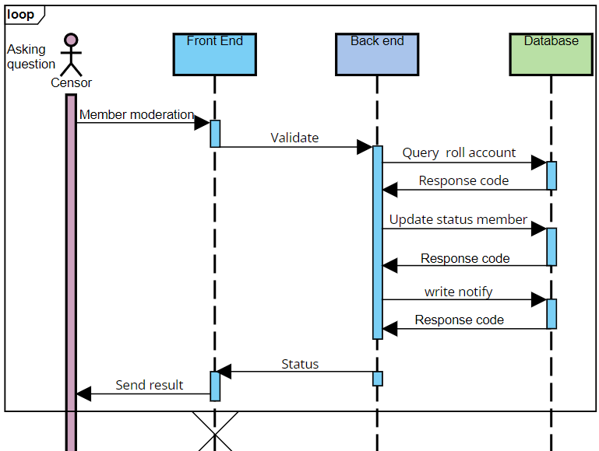

**Description:**

To student teacher can be join in the forum for view create and view post in that forum, censor need censorship that member

Censor are allowed to censorship member in the system, to do that they have login first after that they need request list member need censor from system. They can choose allow that member to access the forum or disallow access to the forum. We service receives requests, calls API to update information and save notify for member in database.

### 3.3.6 view post

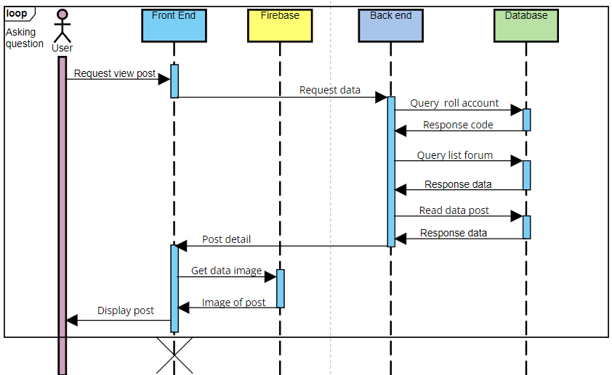

**Description:**

User are allowed to view post in the system, to do that they have to let the system know which forum they want to view post information. We service receives requests, calls API to get data and return post information and take image from firebase if have.

### 3.3.7 Chat

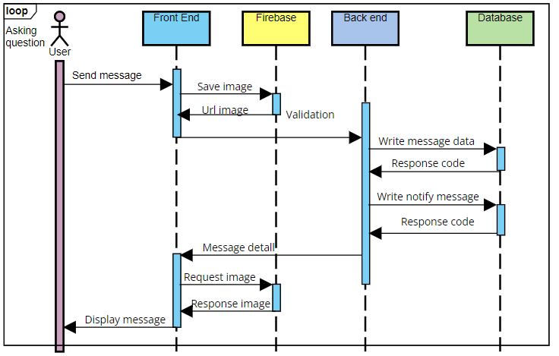

**Description:**

User are allowed to interact with chat send message to another user, input is a chat message. Application reads data if data have image then will save in the firebase and URL and message will save in the database, Serve will send that message to user receive

## 3.4 Module view

1. Module view back end

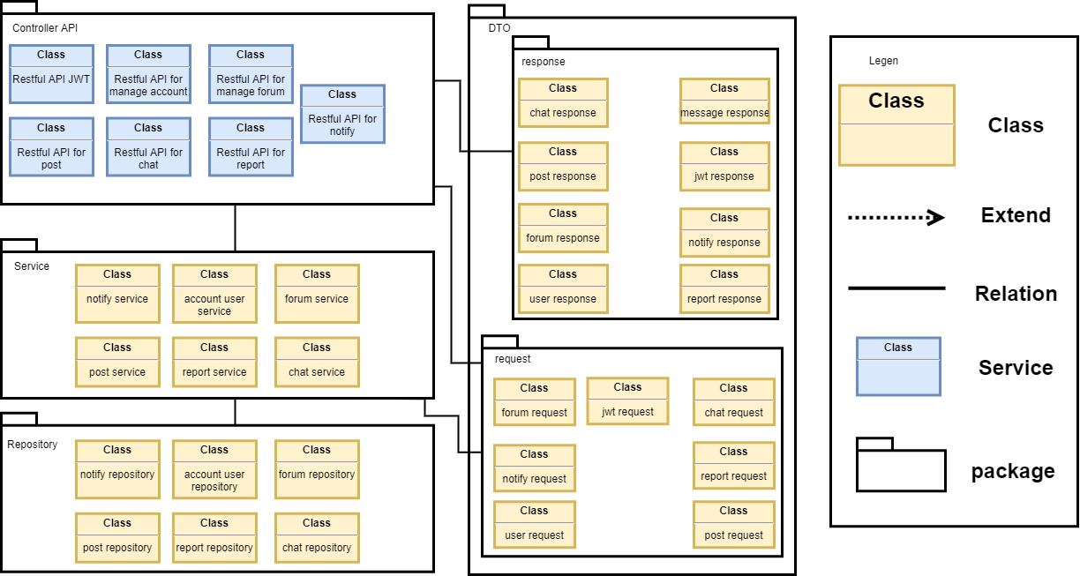

**Prose**

|  |  |
| --- | --- |
| **Element** | **Responsibilities** |
| Controller API | The controller API package contains management and censor, student and teacher to use the functionality of the website modules for take request from front end and send result to front end |
| Service | The service package contains class for logic handling for request of user |
| Repository | The repository package contains class for connection with database and send request write or read database |
| Request | The request package will contain data send from front end |
| Response | The response package will contain data send to front end |

**Description:**

The back end includes app Controller API, service, repository, request, response. After users interact with front end. Data will be requested to the controller API with data contain in request, then will direct to service for logic handling, then will direct to repository for read or write data, then result will direct to controller API then save data in response. Data in response be responded and will be displayed on front end.

## 3.5 Allocation view

The allocation view models the run-time architecture of a system. It shows the configuration of the hardware elements when the system is deployed.

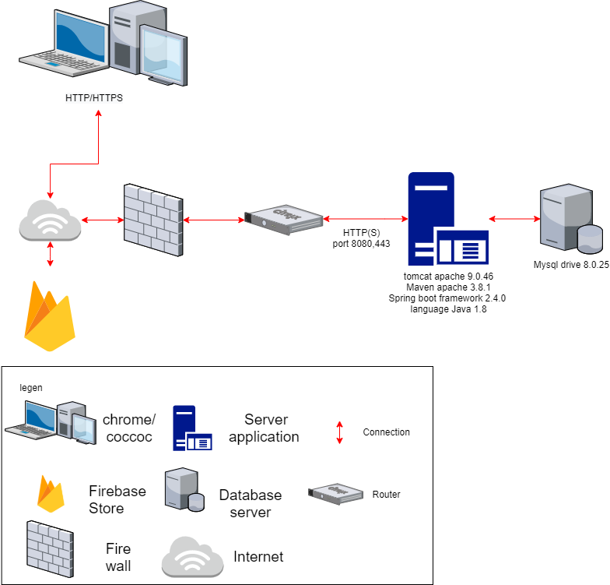

**Prose**

|  |  |
| --- | --- |
| **Element** | **Responsibilities** |
| Laptop or PC | Device running browser and helping user to use the functions of the website. |
| Server Application | Provide an API to support the interaction between the user interface and the server. where to install and run the backend API |
| Mysql Database | The place contains all data about post, user information, forum, ... It is organized in tabular form |
| FireBase store | The place contains all data about image of post, avatar user, forum, ... It is organized in tabular node |

**Description**

The system is deployed on web environment (using VUE JS library). They interact with the server through APIs to read and write data from the MySQL database. In addition, the system interacts with Firebase store to save image of system

# ATAM

## 4.1 Present the ATAM

* Overall evaluation of system architecture documents, system designs on 3 views: static view, dynamic view, and physical view based on ATAM 9 Steps method.
* Expect to achieve an accurate and objective evaluation of the architectural document. From there, the project team assesses the ability to complete the project and achieve the Architecture Drivers.

## 4.2 Present the business Drivers

* The content on the document presented about the following:
  + Who are the business drivers.
  + Business problems and goals for the system are presented by the Project decision makers.
  + System’s features.
  + System’s requirements.
  + Project constraints.
  + Project scope.

## 4.3 Present the Architecture

* Current Architecture state: The design is systematically overviewed on all 3 views: allocation view, module view and component and connector view.
* Expected Architecture state: The architecture is easy to understand, easy to read, full of content, clear and responsive to the constraints and Quality Attributes of the system.
* Impact of following project constraints in the architecture:
  + Time / Deadline: Project will be finished in 119 days (893 hours).
  + Cost / Available resources: 3 people with cost $2266
  + Complexity of the problem: high
  + Quality expectations: Meet the constraints and 4 Quality Attributes described above include: Security, Performance, Correctness and Modifiability.

## 4.4 Identify the Architecture approaches

* Architecture pattern: Client-server architecture
* In the client-server architecture patterns, there are two main components: The client, which is the service requester, and the server, which is the service provider. Although both client and server may be located within the same system, they often communicate over a network on separate hardware. The client component initiates certain interactions with the server to generate the services needed. While the client components have ports that describe the needed services, the servers have ports that describe the services they provide. Both components are linked by request/reply connectors.
* The architectural blueprints are broken down into sections and interact with the services.

## 4.5 Create a Quality Attribute Tree

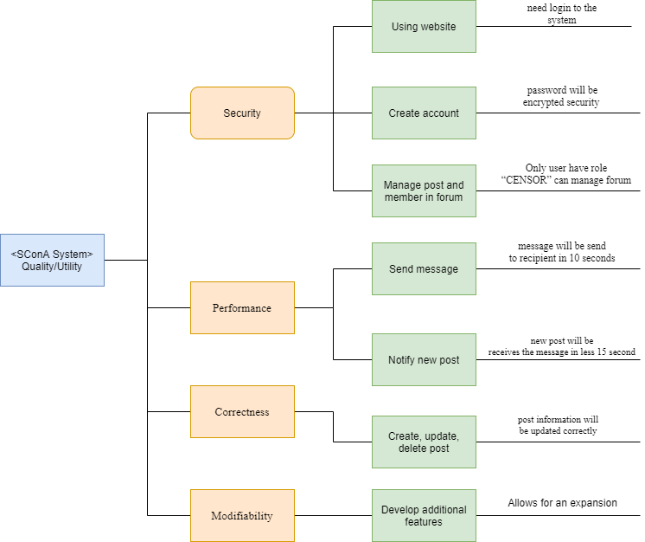

## 4.6 Analyze the Architectural approaches

|  |  |
| --- | --- |
|  | Evaluate |
| Tradeoffs | + With client-server architecture, the performance level is enhanced and the trade-off in system security decreases  + Ease of security pays off with system performance. Meeting good performance reduces ease of security and vice versa |
| Sensitivity points | + Depends quite a lot on the network system and the data transmission speed of the services.  + No data backup solution yet |
| Risk and non-risk scenarios | + When security is threatened, hackers attack services, security can be affected.  + Network problem occurred.  + A service is dead. |

## 4.7 Brainstorm and prioritize scenarios

* Rank priority based on the constraints and attributes(descending):
  + Security
  + Performance
  + Correctness
  + Modifiability

## 4.8 Re-analyze the architectural approaches

* Validate with the system architect to discover and achieve with the system design.

## 4.9 Present the results

* Based on the above reviews:
  + The system can accommodate a number of Quality Attributes and constraints given.
  + However, some systemic risks will appear affecting the system and the Quality Attributes will be in order of priority.

# References:

|  |  |  |
| --- | --- | --- |
| **No.** | **References** | **Document Information** |
| 1 | Design standards,  Document standards | https://www.softwarearchitecturebook.com/svn/main/slides/ppt/26_Standards.ppt |
| https://standards.ieee.org/standard/1471-2000.html |
| https://ieeexplore.ieee.org/document/917550 |
| 2 | Patterns | https://en.wikipedia.org/wiki/Architectural_pattern |
| 3. | Evaluation standards | https://www.iso.org/obp/ui/#iso:std:iso-iec-ieee:42030:ed-1:v1:en |
| https://gabrielfs7.github.io/software-architecture/2019/10/18/atam-analyze-evaluate-architecture/ |